Presentation of results of liquidity chart scraping for Uniswap 3

As per the Uniswap V3 whitepaper : In Uniswap v3, the contract could be thought of as having virtual reserves—values for 𝑥 and 𝑦 that allow you to describe the contract’s behavior (between two
adjacent ticks) as if it followed the constant product formula. Instead of tracking those virtual reserves, however, the pool contract tracks two different values: liquidity (𝐿) and sqrtPrice
(√𝑃).

Based on this I make the assumption that the liquidity column in the data scrapped is the liquidity per tick as each row contains a tick value and also a liquidity value.

CountPlot of Z scores of liquidity

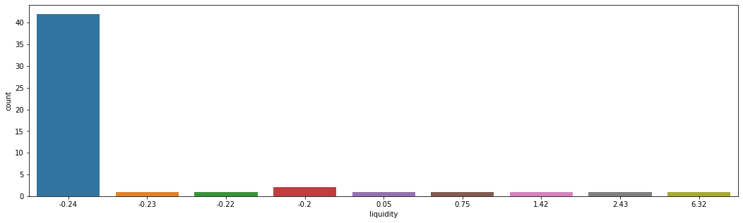

Distribution plot of z scores of liquidity

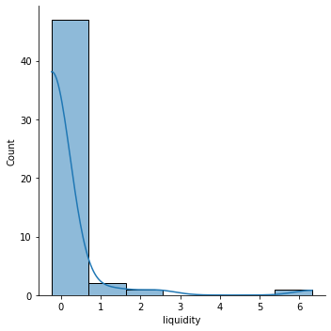

For liquidity per tick here is the statistical summary :

count 5.100000e+01
mean 1.542367e+26
std 6.459196e+26
min 0.000000e+00
25% 3.554859e+18
50% 1.734330e+22
75% 9.713800e+23
max 4.195543e+27
Name: liquidity, dtype: float64

Comment / Analysis of liquidity per tick:

1) Standard deviation is greater than mean means the spread of the data is too much. (Min is 0 and Max is 4.195e+27).
2) As can be ascertained graphically the liquidity is not distributed normally. Hence no statistical tests are applied to check for the same.
3) Most frequent value (40 occurences) of the liquidity per tick is around 0.24 standard deviations less than the mean.
4) 50% of the data is in the range 3.55e+18 to 9.71e+23

As is evident from the boxplot of liquidity there are significant outliers

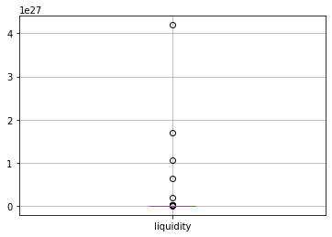

Outlier removal is done once using IQR on liquidity since the data is very dispersed. Plots below are post outlier removal once.

Distribution plot of liquidity

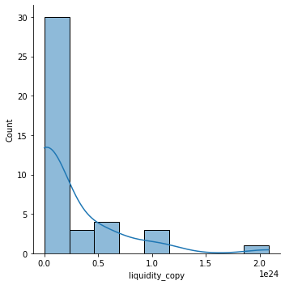

Count plot of Z scores of liquidity

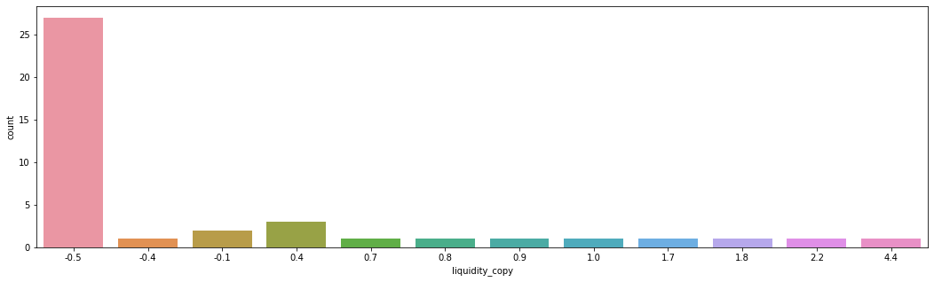

Distribution plot of Z scores of liquidity

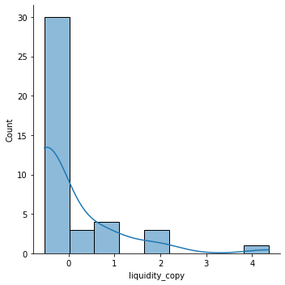

Statistical summary is :

count 4.100000e+01
mean 2.262753e+23
std 4.314407e+23
min 0.000000e+00
25% 2.131926e+18
50% 3.135210e+20
75% 4.024925e+23
max 2.084382e+24
Name: liquidity_copy, dtype: float64

1) Standard deviation is still bigger than mean implying dispersed or very spread out data.
2) Most of the liquidity (30 out of 41 values or 73%) is between -0.5 to 0 standard deviations less than the mean.
3) -0.5 standard deviations less than the mean is the most frequent liquidity value.
3) 50% of the liquidity values lie between 2.13e+18 to 4.02e+23.
4) -0.5 to 0 standard deviations less than the mean equals to the range 0.11+e23 t0 2.26e+23. This range contains 73% of the values.
5) As is evident graphically the distribution is heavily skewed and not normally distributed.

- Tick to dollar price conversion using the formula :
$ price = 1.0001 ^ (-tick) * 10^12
has been done in the Jupyter notebook.

- 'TVL' (Total value locked ≈ assets under management)

Total value locked in USD is given in the data scrapped as a column.

Assets under management for a liquidity pool would be the number of tokens of each type multiplied by their value in USD.

(Volume of token0 * price of token0) + (Volume of token1 * price of token1)

This AUM is not coming equal to Value locked in USD

